# **CTF Challenge: Network Scanning - Using FraudGuard**



# **1. Introduction**

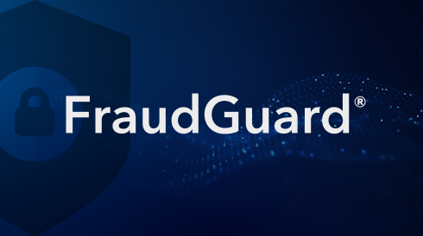

FraudGuard collects and analyzes data to help you understand and respond to internet threats, particularly focusing on fraudulent activities. This challenge will introduce you to FraudGuard to gather information about a specific IP address.

# **2. Tools and Requirements**

Access to the internet and FraudGuard

# **3. Scenario**

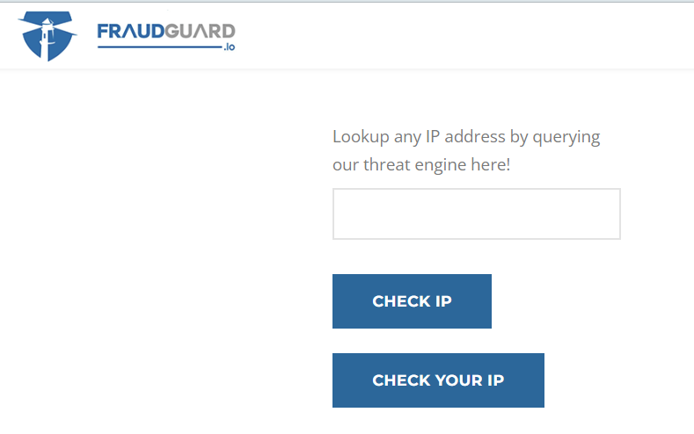

You are an ethical hacker tasked with gathering information about a specific IP Address using FraudGuard. Your job is to determine if the website has been flagged for any malicious activity and identify one recent activity associated with it.

# **4. Process to follow while performing CTF**

Step 1: Go to FraudGuard: [**https://fraudguard.io/**](https://fraudguard.io/)

Step 2: Enter IP **104.244.42.129** in the search bar and click on Check IP option.

Step 3: Solve the CTF.

# **5. Let’s Begin the Challenge**

**Question**

**Flag 1: What is the risk Level of the Ip address?**

*Answer: 1*

**Flag 2: What is the Internet Service Provider of IP Address?**

*Answer: Twitter*

**Flag 3: What is the Connection-type of the IP Address?**

*Answer: Corporate*

**Flag 4: What is the ASN of the IP Address?**

*Answer: 13414*

**Hint:**

